Supplemental Graduate Fellowship and Recruitment

Funding (SGFRF) Program
The Supplemental Graduate Fellowship and Recruitment Funding (SGFRF) Program is aimed at helping graduate programs recruit new graduate students who show exceptional merit and promise. New this year is the added opportunity to apply for the Graduate School’s Center for Inclusive Excellence (CIE) funds to support active plans for Minority Serving Institution (MSI) outreach to foster their diversity and inclusion goals. Departments/interdisciplinary programs may submit one proposal for SGFRF or SGFRF+CIE.

In this document:

SGFRF Funding
CIE Funding
Applications
- Proposal - Narrative
- Proposal - Student Data
Submitting an Application

SGFRF funding:
- is awarded to departments/interdisciplinary programs that demonstrate best practices in graduate education by recruiting, retaining, training, and professionally placing outstanding graduate students.
- can be used for the recruitment strategy that best meets a department’s/program’s needs and goals.
  - for example: to 1) help provide increased student support through a one-year graduate fellowship to one or more meritorious students (specific students do not have to be identified in advance), 2) defray costs of visitation/recruiting events, 3) provide early enrollment support, 4) fund professional development programming for new students, 5) covering the cost of course fees, or 6) other innovative methods to improving graduate program recruiting efforts.
- must be utilized to recruit and support exceptional new students.
- proposals must demonstrate intentional and thoughtful efforts to recruit and support underrepresented minority (URM) students.
- utilized as a one-year fellowship for an incoming student must be awarded as a supplement to a .50 FTE departmental teaching or research assistantship or an additional departmental fellowship. This demonstrates departmental financial support of the student beyond this one-time fellowship. Students receiving the supplemental fellowships must be enrolled as full-time graduate students.

CIE Funding:
CIE funding can be used for recruitment activities including:
- Visiting an eligible Minority Serving Institution (MSI), e.g., Historically Black College or University (HBCU), Hispanic Serving Institution (HSI), and/or Tribal Colleges or Universities (TCU) to give a seminar/lecture or other academic-related activity in which they will connect with faculty and students at the institution.
- Extending a trip to a conference to visit with counterparts or programs of interest in a nearby eligible institution.
- Arranging work visits to develop a Memorandum of Agreement/Understanding or begin the development of a relationship towards that intent with an eligible institution.
- Bringing professors from eligible institutions to visit campus to showcase the MU department/program, as well as to showcase the eligible institution to MU faculty, to develop a pathway/pipeline relationship.
  - CIE fund eligible expenses include: Travel (airfare/mileage); Lodging; and Per diem

Applications
The Graduate School seeks proposals for the SGFRF Program to help academic units recruit outstanding graduate students new to MU starting the following summer or fall semester. Programs requesting funds for recruitment activities other than supplemental fellowships should describe the activities with sufficient detail to allow for review using the SGFRF rubric available on the Graduate School website.
All departments/interdisciplinary programs funded through the SGFRF Program will be expected to demonstrate the successes of their students. The program seeks to reward and encourage department/program excellence; it does not seek to remediate low stipend levels. Therefore, the application should focus on department/program strengths and improvements.
SGFRF and SGFRF+CIE funds must be used within one calendar year period from the notification of the award. (Occasional exceptions may be granted when strong justification is provided, and funds remain available.)
The total length of an application should not exceed 9 pages, including Cover Sheet, Proposal Narrative, and Proposal Student Data.
Departments/interdisciplinary programs may submit proposals for one of the following two options. Please note that departments/programs may only submit one proposal.
  - SGFRF proposal up to $10,000 to support graduate recruitment efforts. Requested funds are from the SGFRF Program and do not include CIE fund recruitment activities.
  - SGFRF+CIE proposal up to $12,000 to support graduate recruitment efforts, including SGFRF (e.g., supplemental fellowship and recruitment activities) as well as CIE fund recruitment activities. Note: Supplemental fellowships will come from the SGFRF Program not CIE fund. CIE fund will only be used for the CIE fund eligible activities and expenses. Up to $5,000 of your budget may be allocated for CIE fund recruitment activities.

Proposal Narrative (2-3 pages, single-spaced)
The narrative must include information related to the life cycle of graduate education in the department or program from recruitment to successful completion. The narrative should include:
- Description of recruitment and admissions processes for your department or interdisciplinary program. Describe any special efforts made to ensure a good fit between student, faculty, and department/program. Describe specific efforts or programming designed to attract and admit underrepresented students, with an acknowledgement that disciplines define “underrepresented” differently. State the financial commitments typically made to incoming students.

- Description of retention efforts in your department/interdisciplinary program. Describe efforts at successful orientations, handbooks, mentoring, seminars, and special programs of a social and/or academic nature that encourage:
    - Faculty/student interaction
    - Integration of students in the teaching, research, and outreach missions of the department/program
    - Efforts designed to help students find appropriate mentors or mentoring networks, beyond their faculty advisor
    - Program structures, including curricula and examinations, that enable successful graduate education
- Description of proposed use of funds to recruit students to your graduate program(s). Provide an overview of the use of funds, including a strong rationale for the use of those funds to attract exceptional students and underrepresented students to your department or program. Please also include a funding table with breakdown of expenses.

Proposal Student Data (no more than 5 pages)
Visit the Graduate School’s data analytics to search for your program data: https://gradschool.missouri.edu/graduate-program-statistics/ Select your program name (as listed in the dropdown menu) to view your five-year student data.

Report the following data:

- Screen capture image(s) of your program data for admissions, demographics, tuition support, and stipend support. See examples on next page.
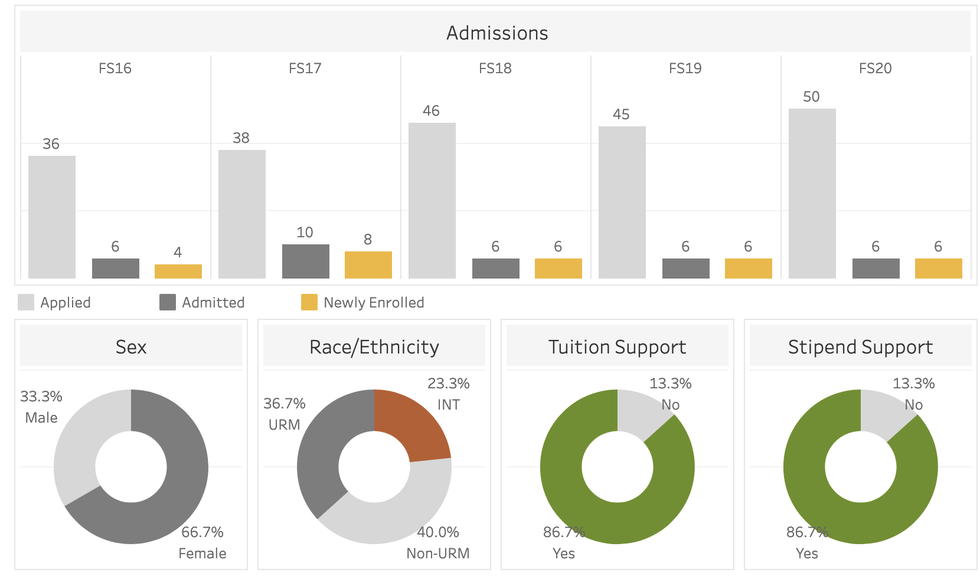

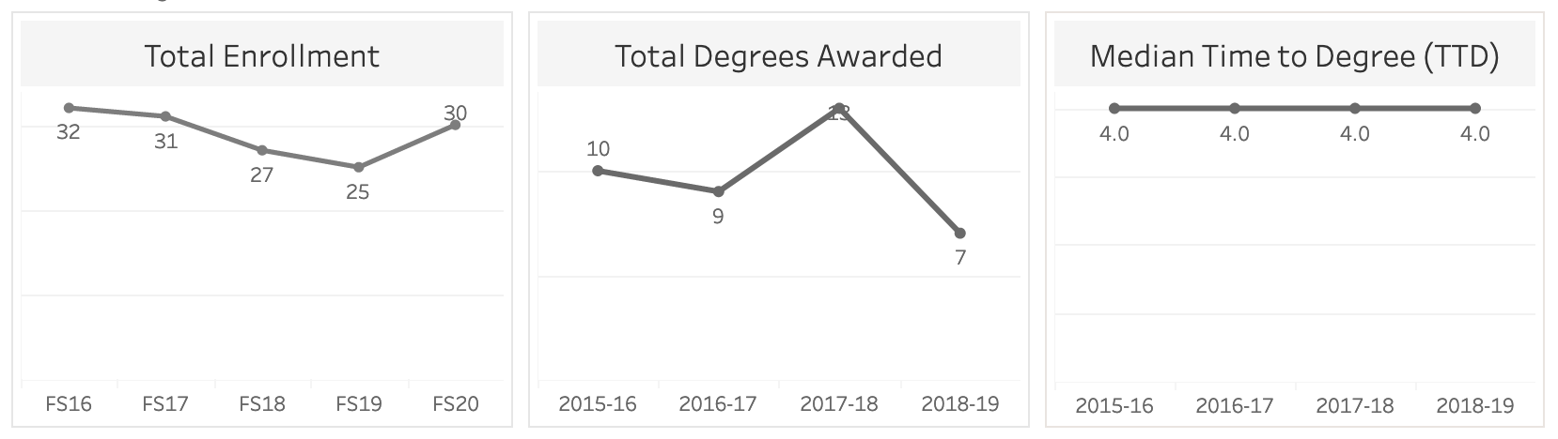

- Retention data for the past 5 years. You will have to report these data from your departmental files. (The Graduate School does not have these data to provide to you.) How many students have left the PhD program before completing, or mastered out of the PhD program? Provide a brief description to provide context and to address why a student mastered out or left the program. (Student names should not be included in these data to protect confidentiality.)

- First-destination placement data for the past 5 years. The data for the class of 2020 are also available on the Graduate School website. You may also have data for the class of 2021 from the spreadsheets Heather Hoffman shared with each department/program for verification. Please utilize your internal records to report additional placement data as available. We do not need student names; you can provide aggregate data for your department. (e.g., number/percent in various types of positions and universities [please specify universities and positions], industry, etc.) The tab “employment” for the career outcomes data on the Graduate School website includes a list of industries you may choose to use.

- Optional: any other data points you feel are relevant to your discipline.

Submitting an Application:
- Applications must be submitted by the DGS or Department Chair/Director of the department/interdisciplinary program.
- Departments/interdisciplinary programs must submit their application materials as a single PDF document titled Department/Program Name_SGFRF (e.g., Chemistry_SGFRF)
to the MUGradFellowshipsNom@missouri.edu inbox.
- Applications are due by 5 PM (Central) on November 16, 2022.
A complete application will include a 1) SGFRF Program Cover Sheet, 2) Proposal Narrative, and 3) Proposal Student Data.
- A panel of faculty reviews the applications and recommends award decisions to the Graduate School. The notification of SGFRF and SGFRF+CIE Awards will be communicated before the University observed winter break in late December.

