

INDIVIDUAL DEVELOPMENT PLAN (IDP)

An Individual Development Plan (IDP) is an essential planning document that identifies your goals and objectives. It is expected that all graduate students will utilize an IDP throughout their graduate experience, with the assistance of their advisor/faculty mentor. Use the University of Missouri Graduate School’s fillable IDP template, as well as programming aligned with our gradESSENTIALS program of professional development categories.

STEPS | FOR GRADUATE STUDENTS … | FOR ADVISOR/MENTORS…
1 | Take inventory of yourself. Reflect on skills, strengths, and areas for development. Outline long-term career objectives. | Become familiar with available career and professional development opportunities.
2 | Consider career and professional development opportunities with mentor. Prioritize your goals. Select opportunities of interest. | Discuss career and professional development opportunities with student.
3 | Write an IDP and share with your advisor and/or mentor. Revise IDP based on feedback and suggestions. | Review the IDP, discuss it with student, suggest (and assist with) revisions.
4 | Implement the plan, and revise IDP as needed, at least annually. Use the IDP as part of annual review with your academic department. | Establish regular review of progress and help revise the IDP as needed, at least annually. Use the IDP as part of annual review of graduate student progress.

EXPECTATIONS
Student
- Take primary responsibility for the successful completion of my degree, and my personal and professional development
- Actively seek out advice and feedback from my advisor, faculty mentor(s), committee, peers, and colleagues
- Meet regularly with my advisor and faculty mentor(s); provide them with updates on the progress and results of my activities
Advisor/Mentor
- Be committed to a student’s education, training, and holistic development as a future member of the professional community
- Encourage students to set reasonable goals and establish a timeline for completion, providing honest feedback on an ongoing basis
- Lead by example and facilitate training in complementary skills needed to for a successful career, utilizing the MU Graduate School’s gradESSENTIALS program as a framework for guiding students



The MU Graduate School has identified essential transferable skills important to the graduate student experience. These skills are incorporated throughout the IDP. The following descriptions will assist you in preparing for the self-reflection portion of the IDP process. A full description of gradESSENTIALS, as well as a list of in-person and online resources may be found at: https://gradschool.missouri.edu/grad-essentials/
Job search strategies; preparing job search materials (resume, CV, cover letter); strengthening interviewing & negotiating skills; building a personal brand and network; entrepreneurship.



Designing curriculum; facilitating discussion; providing constructive feedback; training in teaching technologies & modalities; creating inclusive & supportive class environments.



Public speaking; explaining research to lay audiences; persuading others; learning specialized writing skills; digital literacy & responsibility; adhering to ethical conduct & integrity.
Pursuing answers to complex questions; conducting responsible research; grant writing; finding sources of funding; presenting and publishing your research.



Maintaining physical, mental, & emotional health; adopting self-care strategies; building resilience & emotional intelligence; taking ownership of goal setting, organization, & decision making; managing financial resources; exploring work-life integration;
Valuing differences & similarities; working across disciplines; engaging in new ideas & perspectives; being an ally & advocate; promoting equitable, inclusive, & respectful environments.

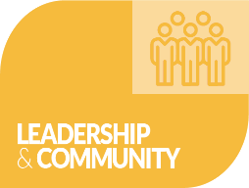
Obtaining depth/breadth of knowledge in subject area; demonstrating critical & analytical thinking & problem solving; keeping track of academic benchmarks, forms, & deadlines; successfully completing graduate milestones (e.g., qualifying exams, theses, dissertations).
Exploring leadership philosophies & styles; understanding organizational dynamics, supervising & mentoring diverse individuals & teams; practicing conflict resolution; participating in project management; appreciating civic engagement.


Creating an IDP
Self-Reflection: Use this list of questions as a starting point for self-reflection:
Step 1
What are my… | Fill in your response:
Career goals?

Strengths & challenges?

Short-term & long-term goals for academic & professional success

Indicate your perception of your level of confidence/competence on these transferable skills. Place an “X” or checkmark to indicate your rating. Or you can add a note to reflect on your level of competence.
gradESSENTIALS | Low Confidence/ Low Competence | Some Confidence/ Some Competence | High Confidence/ High Competence
Career development and exploration
Research and innovation
Inclusive excellence
Leadership and community
Teaching and learning
Communication and professionalism
Health and wellness
Scholarly development

Prioritize Your Goals: These are considerations as you create and adjust a
professional development plan specific to your academic experience, as well as your
personal and professional goals:
Step 2
- What career line interests you? Faculty? Administration? Industry? Policy?
- How to organize the IDP into the areas you hope to grow?
      - Academic focus areas of teaching, research, and service
      - Skills specific to your field
      - Involvement and leadership in campus, community, and professional associations
Review the goals you are developing to assess the viability of your plan.
Are they SMART?
Specific: Have I made clear precisely what needs to happen in each area?
Measurable: Will I know whether I have achieved my objective or not?
Attainable: Are the goals and objectives doable?
Result-oriented: Will my plan and strategy help to move me toward my goals?
Time-limited: Does the plan include realistic time points and due dates?

Step 3

Write an IDP: Use the IDP template (page 6) to lay out your goals for the coming
year. What do you want to achieve?

- Consider how you may want to grow within the categories identified in gradESSENTIALS; check benchmarks in your academic department and college
- Remember the categories are meant to be used as a guide
- Think about all areas of your life and how you might grow personally and professionally; do not rely solely on your academic program or the university for your professional development, as opportunities are found in many places
- The IDP does not have to be filled out completely – it is for YOUR goals
Step 4
Revise IDP: As needed, at least annually
- Meet with your advisor and/or faculty mentor to discuss the IDP, progress made, and to set new goals. The IDP can be helpful for discuss annual review feedback.
- Build your professional portfolio. As your skills build, be sure to incorporate your experiences into your job search materials. Depending on your career goals, the following list are examples of items you may need to develop as you prepare for the job search:
Cover letter | Teaching philosophy | Student evaluations from teaching
CV/Resume | Research statement | Professional headshot
Reference list | Diversity statement | Brief bio

IDP Template

Name: ___________________________________________________________________________________
Degree Program: __________________________________________________________________________
Advisor/mentor: ___________________________________________________________________________
Director of Graduate Studies (DGS): __________________________________________________________
Date IDP created: __________________________________________________________________________
Date IDP updated (if applicable): _____________________________________________________________
Advisor signature (if applicable): _____________________________________________________________

Remember the categories are meant to be used as a guide; you do not have to write goals for every category, or have 3 goals for each category in the IDP template.


Scholarly Development
(academic milestones, subject area expertise)
Obtaining depth/breadth of knowledge in subject area; demonstrating critical & analytical thinking & problem solving; keeping track of academic benchmarks,
forms, & deadlines; successfully completing graduate milestones (e.g., qualifying exams, theses, dissertations).
Goals for upcoming year | Actions | Resources | Timeline | Notes
Goal 1
Goal 2
Goal 3
Accomplishments and Experiences: An optional space to keep track of your notable accomplishments, new or memorable experience that helped shape your worldview:

Remember the categories are meant to be used as a guide; you do not have to write goals for every category, or have 3 goals for each category in the IDP template.

Research & Innovation
Pursuing answers to complex questions; conducting responsible research; grant writing; finding sources of funding; presenting and publishing your research.

Goals for upcoming year | Actions | Resources | Timeline | Notes
Goal 1
Goal 2
Goal 3
Accomplishments and Experiences: An optional space to keep track of your notable accomplishments, new or memorable experience that helped shape your worldview:

Remember the categories are meant to be used as a guide; you do not have to write goals for every category, or have 3 goals for each category in the IDP template.


Career Development & Exploration
Job search strategies; preparing job search materials (resume, CV, cover letter); strengthening interviewing & negotiating skills; building a personal brand and network; entrepreneurship.

Goals for upcoming year | Actions | Resources | Timeline | Notes
Goal 1
Goal 2
Goal 3

Accomplishments and Experiences: An optional space to keep track of your notable accomplishments, new or memorable experience that helped shape your worldview:

Remember the categories are meant to be used as a guide; you do not have to write goals for every category, or have 3 goals for each category in the IDP template.

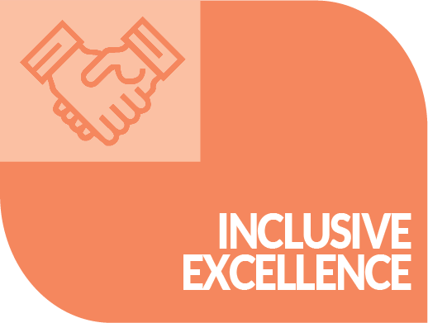
Inclusive Excellence
Valuing differences & similarities; working across disciplines; engaging in new ideas & perspectives; being an ally & advocate; promoting equitable, inclusive, & respectful environments.

Goals for upcoming year | Actions | Resources | Timeline | Notes
Goal 1
Goal 2
Goal 3

Accomplishments and Experiences: An optional space to keep track of your notable accomplishments, new or memorable experience that helped shape your worldview:

Remember the categories are meant to be used as a guide; you do not have to write goals for every category, or have 3 goals for each category in the IDP template.

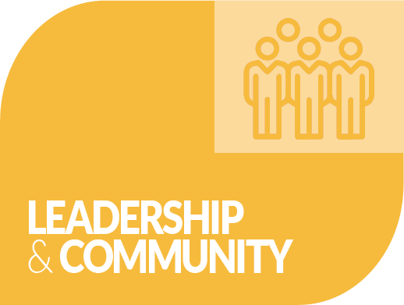
Leadership & Community Engagement
Exploring leadership philosophies & styles; understanding organizational dynamics, supervising & mentoring diverse individuals & teams; practicing conflict resolution;
participating in project management; appreciating civic engagement.

Goals for upcoming year | Actions | Resources | Timeline | Notes
Goal 1
Goal 2
Goal 3

Accomplishments and Experiences: An optional space to keep track of your notable accomplishments, new or memorable experience that helped shape your worldview:

Remember the categories are meant to be used as a guide; you do not have to write goals for every category, or have 3 goals for each category in the IDP template.


Teaching & Learning
Designing curriculum; facilitating discussion; providing constructive feedback; training in teaching technologies & modalities; creating inclusive & supportive class environments.

Goals for upcoming year | Actions | Resources | Timeline | Notes
Goal 1
Goal 2
Goal 3
Accomplishments and Experiences: An optional space to keep track of your notable accomplishments, new or memorable experience that helped shape your worldview:

Remember the categories are meant to be used as a guide; you do not have to write goals for every category, or have 3 goals for each category in the IDP template.


Communication & Professionalism
Public speaking; explaining research to lay audiences; persuading others; learning specialized writing skills; digital literacy & responsibility; adhering to ethical conduct & integrity.

Goals for upcoming year | Actions | Resources | Timeline | Notes
Goal 1
Goal 2
Goal 3
Accomplishments and Experiences: An optional space to keep track of your notable accomplishments, new or memorable experience that helped shape your worldview:

Remember the categories are meant to be used as a guide; you do not have to write goals for every category, or have 3 goals for each category in the IDP template.


Health & Wellness
Maintaining physical, mental, & emotional health; adopting self-care strategies; building resilience & emotional intelligence; taking ownership of goal setting, organization, & decision making; managing financial resources; exploring work-life integration.

Goals for upcoming year | Actions | Resources | Timeline | Notes
Goal 1
Goal 2
Goal 3

Accomplishments and Experiences: An optional space to keep track of your notable accomplishments, new or memorable experience that helped shape your worldview:

Additional Category (e.g. practicums, clinical experience, entrepreneurship):
Goals for upcoming year | Actions | Resources | Timeline | Notes
Goal 1
Goal 2
Goal 3
Additional Category (e.g. practicums, clinical experience, entrepreneurship):
Goals for upcoming year | Actions | Resources | Timeline | Notes
Goal 1
Goal 2
Goal 3

